# **Requirement**

Install Java Virtual Machine(JVM): To launch PPMaP runnable

Install R software: To install R package and launch Rserve to execution!

Install R package with this command line in the console!

install.packages(c("minpack.lm","MASS", "sp","maptools", "rgdal", "maps","doRNG","Rserve"), dependencies = T)

#Once the installation of the packages is completed, execute the following two(2) command in the console to launch Rserve

library(Rserve)

Rserve()

Now double-click on PPMaP_1.0.jar to launch the software! and this window appear.

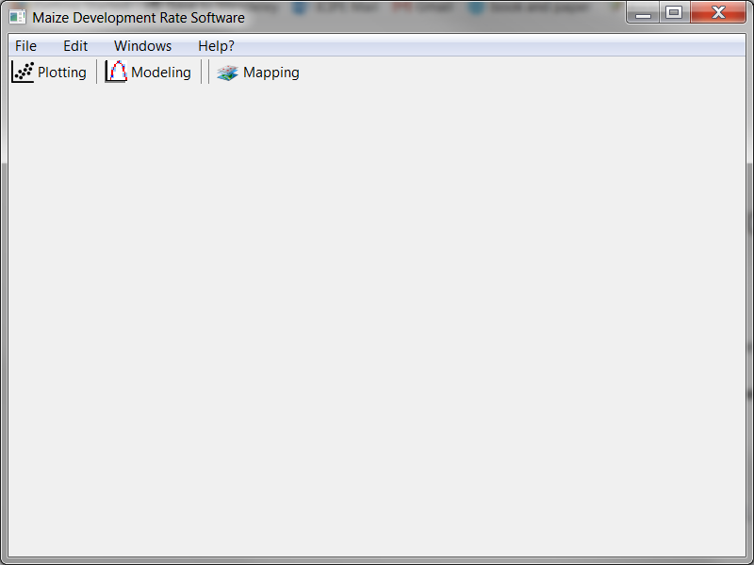

# **Create a new project**

To create a new project, go to **File -> New -> Project**

A window opens to input information as show in the figure below. Click on “**Finish**” button when completed.

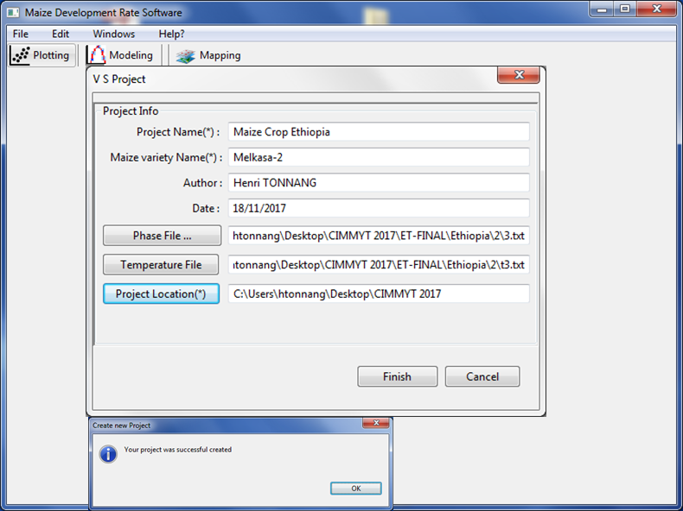

# **Plotting data**

To plot and observe data, click on the related button “**Plotting**” in the toolbar of the main window!! In the frame which open,

Select the development phase you want to visualize the data (at the top left of the window)

Click on the button “**Load and Plot** “ to load and plot data of the stage (at the bottom right of the window).

Click on the button “**Adjust graph**” if you want to make some modification of the graph.

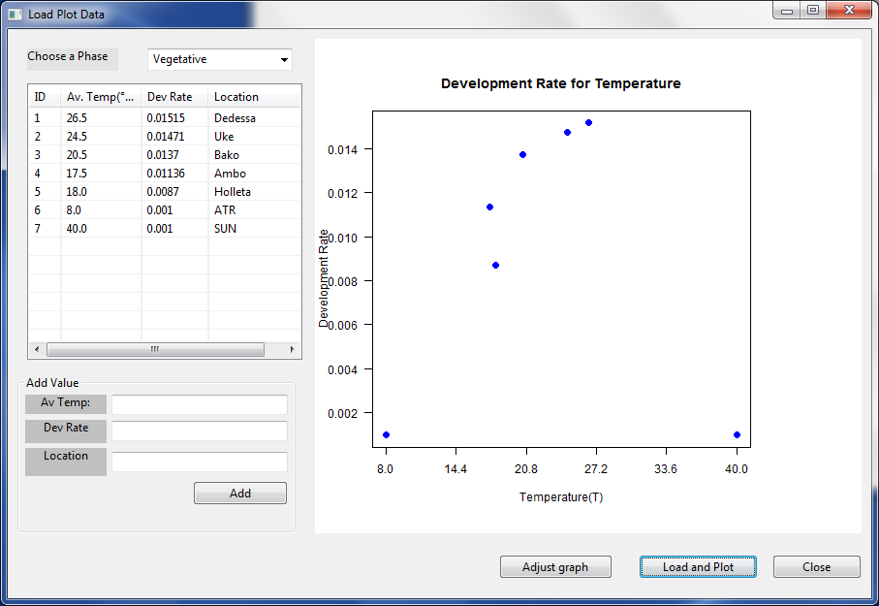

# **Temperature-dependent model.**

To build the temperature-dependent- development rate model, click on the related button “**Modelling**” in the toolbar of the main window!! the frame which open (see the figure below) shows the library of mathematical expressions that are used to describe the relationship between the plant phase development and temperature. The left box contains the models characterized by the name of the author that pioneers the formulation. The centre box contains the sub-models, which are derivative of the models from the left box. The right box contains the models selected for fitting. For example, in Briere***i***, the indice *i* represents the number of the derived model from the original Briere model. To proceed,

Select the development phase you want to model

Select models will be used to build the temperature-dependent- development model, then click on the “**next**” button.

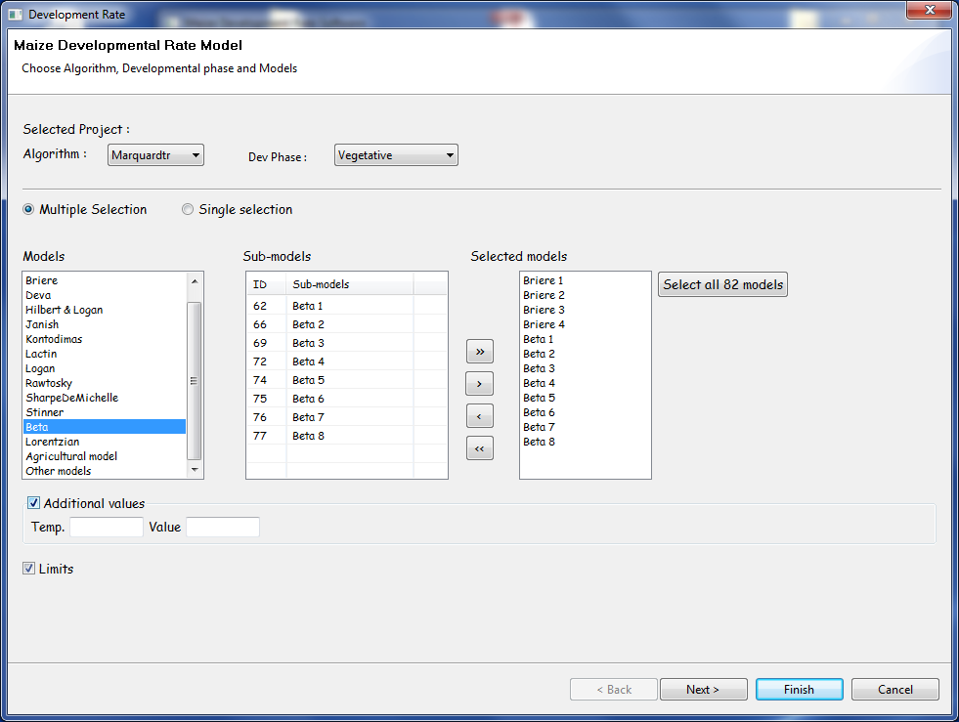

After pressing on the “**next**” Button, you have

(A) Window of the PPMaP software presenting diverse models, each with corresponding models selection criteria for comparison; usually the best model has the smallest value of Akaike’s Information Criterion (AIC). (B) Example of points of data (blue) for a variety of maize at the vegetative phase fitted by Briere temperature dependent mathematical expression (red curve). (C) The statistical criteria for model selection, the model parameters and the (ANOVA) analysis of variances are shown.

Using visual observation and value of selection criteria, choose the best model by clicking “Accept” in the window of the best model.

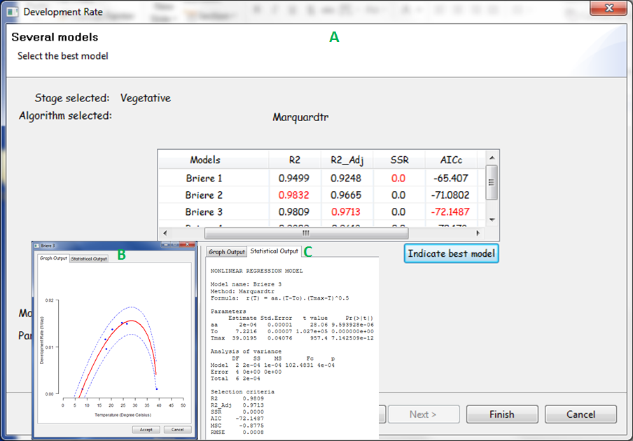

# **Mapping!**

To proceed with the mapping of the number of day of a giving phase using a model, click on the related button “**Mapping**” in the toolbar of the main window, the frame below opens

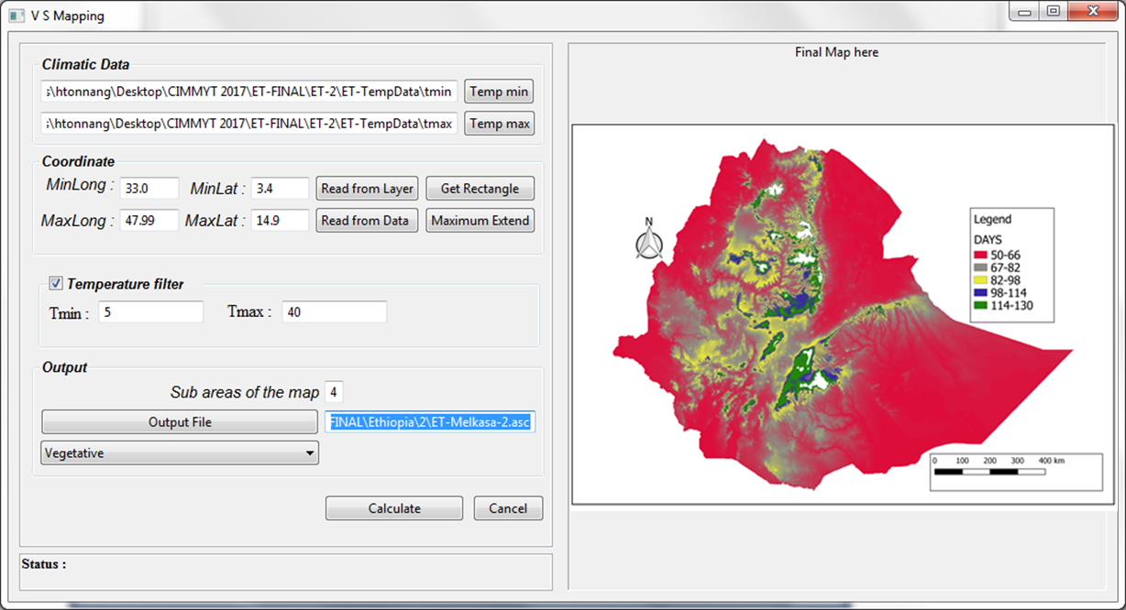

Insert the input and click on “**Calculate**” to generate the map. These input are, the paths for inputting minimum and maximum temperature of the area of interest, below these paths are the extend coordinates of the region chosen for mapping; the range of temperature to consider for the mapping process. For example, we have here the map of Ethiopia showing the number of days a maize variety could spend during the vegetative phase appeared in a box at right. Depending on the location, this maize variety can spend from 50 to 130 days in order to start flowering